**React Introduction**

**ReactJS**, also known as **React**, is a popular JavaScript library for building user interfaces.

It is also referred to as a front-end JavaScript library.

It was developed by **Facebook** and is widely used for creating dynamic and interactive web applications.

**‍What is React?**

**React** is a **JavaScript library** for building **user interfaces** (UIs) on the web.

React is a declarative, component based library that allows developers to build reusable UI components and it follows the Virtual DOM (Document Object Model) approach, which optimizes rendering performance by minimizing DOM updates.

React is **fast** and works well with other tools and libraries.

***Prerequisite of React***

*For learning React first you have a clear understanding of HTML, CSS and JavaScript.*

*As React is a JavaScript library and uses most of its concept so you really have to understand the major concepts of it.*

**History of React**

* React was invented by Facebook developers who found the traditional DOM slow.
* By implementing a virtual DOM, React addressed this issue and gained popularity rapidly.
* The current stable version of React is 18.2.0, released on June 14, 2022.
* The library continues to evolve, introducing new features with each update.

**How does React work?**

React operates by creating an in-memory virtual DOM rather than directly manipulating the browser’s DOM.

It performs necessary manipulations within this virtual representation before applying changes to the actual browser DOM.

React is efficient, altering only what requires modification.

**Features of React**

React is one of the most demanding JavaScript library because it is equipped with a ton of features which makes it faster and production-ready.

Below are the few features of React.

**1. Component-Based Architecture**

React provides the feature to break down the UI into smaller, self-contained components.

Each component can have its own **state and props**.

**2. JSX (JavaScript Syntax Extension)**

JSX is a syntax extension for JavaScript that allows developers to write HTML-like code within their JavaScript files.

It makes React components more readable and expressive.

const name="Ramesh";

const ele = <h1>Welcome to {name}</h1>;

**3. Virtual DOM**

React maintains a lightweight representation of the actual DOM in memory.

When changes occur, React efficiently updates only the necessary parts of the DOM.

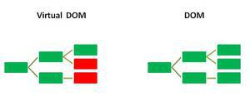

**4. One-way Data Binding**

One-way data binding, the name itself says that it is a one-direction flow.

The data in react flows only in one direction i.e. the data is transferred from top to bottom i.e. from parent components to child components.

The properties (props) in the child component cannot return the data to its parent component but it can have communication with the parent components to modify the states according to the provided inputs.

**5. Performance**

As we discussed earlier, react uses virtual DOM and updates only the modified parts.

So, this makes the DOM to run faster.

DOM executes in memory so we can create separate components which makes the DOM run faster.

**6. Components**

React divides the web page into multiple components as it is component-based.

Each component is a part of the UI design which has its own logic and design as shown in the below image.

So the component logic which is written in JavaScript makes it easy and run faster and can be reusable.

**7. Single-Page Applications (SPAs)**

React is recommended in creating SPAs, allowing smooth content updates without page reloads.

Its focus on reusable components makes it ideal for real-time applications.

**ReactJS Lifecycle**

Every React Component has a lifecycle of its own, lifecycle of a component can be defined as the series of methods that are invoked in different stages of the component’s existence.

React automatically calls these methods at different points in a component’s life cycle.

Understanding these phases helps manage state, perform side effects, and optimize components effectively.

**1. Initialization**

This is the stage where the component is constructed with the given Props and default state.

This is done in the constructor of a Component Class.

**2. Mounting Phase**

* **Constructor**:

The constructor method initializes the component.

It’s where you set up initial state and bind event handlers.

* **render():**

This method returns the JSX representation of the component.

It’s called during initial rendering and subsequent updates.

* **componentDidMount():**

After the component is inserted into the DOM, this method is invoked.

Use it for side effects like data fetching or setting timers.

**3. Updating Phase**

* **componentDidUpdate(prevProps, prevState)**:

Called after the component updates due to new props or state changes.

Handle side effects here.

* **shouldComponentUpdate(nextProps, nextState):** Determines if the component should re-render. Optimize performance by customizing this method.
* **render():** Again, the render() method reflects changes in state or props during updates.

**4. Unmounting Phase**

* **componentWillUnmount()**: Invoked just before the component is removed from the DOM. Clean up resources (e.g., event listeners, timers).

**FAQs on React**

**Is React a framework or library?**

*It is very confusing to a lot of people that if React is a framework of a library.*

*React is considered as a library rather than a framework.*

*While in the framework there is a controlled way of structure to write the code whether in library you are free to write without any structural restriction.*

**How do I Start Learning React?**

*React has a large community that keeps updating all the concepts of React.*

*You just need to follow proper step by step roadmap to learn React and keep hands on practice on it.*

**What is JSX?**

*JSX, which stands for JavaScript XML, is a syntax extension for JavaScript.*

*ReactJS uses an XML or HTML-like syntax, which is then transformed into React Framework JavaScript calls.*

*Essentially, JSX expands ES6 to allow HTML-like text to coexist with JavaScript   
React code.*

*Although it is not mandatory to use JSX in ReactJS, it is highly recommended.*

***Syntax:***

*const example = “JSX”*

*const ele = <div>This component uses {example} </div>*

**Is React Beginner Friendly?**

*Yes, React is very simple and beginner friendly.*

*It just uses JavaScript and JSX to create the Single page Application.*

*If you have the basic knowledge of HTML, CSS and JavaScript you are good to go to dive deep into the React world.*

**Topics in React**

To learn React, it's best to approach the topics in a logical sequence, building from foundational concepts to more complex patterns and best practices. Here's a suggested sequence for learning React, from beginner to advanced:

1. **JavaScript Fundamentals**:
   * Ensure you have a strong grasp of JavaScript, including ES6+ features like arrow functions, destructuring, template literals, and the spread/rest operators.
2. **Basic React Concepts**:
   * **Introduction to React**: Understand what React is and why it's used for building user interfaces.
   * **JSX**: Learn how JSX allows you to write React components in a syntax resembling HTML, but with JavaScript functionality.
   * **Components**: Understand functional and class-based components, the building blocks of React applications.
   * **Props and State**: Learn about props (data passed to components) and state (data within a component).
3. **Advanced React Concepts**:
   * **Event Handling**: Learn how to handle events in React components, such as clicks and form submissions.
   * **Conditional Rendering**: Understand how to render components based on conditions.
   * **Lists and Keys**: Learn how to render lists of items and why keys are important.
   * **Lifecycle Methods**: If learning class components, explore lifecycle methods like **componentDidMount**.
   * **Hooks**: Dive into hooks like **useState**, **useEffect**, **useContext**, and **useReducer** for state management and lifecycle control.
4. **Component Composition and Reusability**:
   * **Higher-Order Components (HOCs)**: Learn about this older pattern for reusing component logic (though less commonly used with modern hooks).
   * **Custom Hooks**: Create your own reusable hooks to encapsulate logic.
   * **Context API**: Explore how React's context system allows you to share data across components without prop drilling.
5. **State Management**:
   * **Local State Management**: Understand how state is managed within individual components.
   * **Global State Management**: Learn about solutions like Redux, MobX, or the Context API for managing state across an application.
   * **Reducers**: Learn how to use reducers for complex state management with **useReducer** or Redux.
6. **Routing and Navigation**:
   * **React Router**: Learn how to navigate between pages and manage complex routing.
   * **Dynamic Routing**: Explore how to create routes with parameters and nested routes.
7. **Styling and UI Components**:
   * **Styling Approaches**: Learn about CSS, CSS-in-JS, Styled Components, and other styling methods in React.
   * **UI Component Libraries**: Explore libraries like Material-UI, Ant Design, or Tailwind CSS for building consistent UIs.
8. **Advanced React Techniques**:
   * **Performance Optimization**: Learn about memoization with **React.memo** and **useMemo**, as well as **useCallback**.
   * **Server-Side Rendering (SSR) and Static Site Generation (SSG)**: Explore frameworks like Next.js for server-side rendering and static site generation.
   * **Code Splitting and Lazy Loading**: Understand how to improve performance by splitting code and loading components asynchronously.
9. **Testing and Debugging**:
   * **Testing Frameworks**: Learn about testing libraries like Jest and React Testing Library.
   * **Debugging Tools**: Explore tools like React DevTools and how to debug React applications.
10. **Deployment and Production**:
    * **Build Tools**: Understand tools like Webpack, Babel, and Create React App.
    * **Deployment**: Learn how to deploy React applications to platforms like Netlify, Vercel, or AWS.
    * **Continuous Integration/Continuous Deployment (CI/CD)**: Explore automated deployment and integration workflows.

This sequence provides a comprehensive roadmap for learning React, from the basics to advanced concepts, including state management, routing, and testing. Depending on your specific interests and project needs, you can adjust the focus and depth of your learning in each area.

**Installing React**

To install React, you’ll need Node.js and npm (Node Package Manager) installed on your system.

Once you have those set up, you can create a new React application using Create React App, which is an officially supported way to create single-page React applications.

Here’s a step-by-step guide to get you started:

1. **Install Node.js and npm**: **(install node-v20.18.0-x64).**
   * Visit the [Node.js website](https://nodejs.org/) to download and install the latest version of Node.js, which includes npm. Or
   * Type the command as shown below in VSCode terminal

**npm install node.js**

1. **Installing create-react-app application**:
   * Open your terminal or command prompt.
   * Run the following command to install Create React App globally (if you haven’t already):

**npm install -g create-react-app**

**Introduction to Create React App**

The most common way to get started with React is to use a node package called **Create React App**.

**Create React App** is an officially supported tool that installs a toolchain for React development and configures a boilerplate React application that you can use as a starting point for your applications.

To install and run **Create React App**, you can use a command that comes as part of the npm package manager called npx.

**Npx is a package runner.**

To create a new React app using Create React App, use the npx command, followed by **create-react-app**, followed by a name that you want to give your new React app.

**For example:**

**> npx create-react-app** **my-new-app**

> cd my-new-app

> npm start

**Naming Your React App**

The name you choose for your new app is up to you, as long as it conforms to the rules of Node.js package names.

These rules are:

➤ It must be less than 214 characters long.

➤ The name can’t start with a dot or underscore.

➤ The name can’t have uppercase letters.

➤ It can’t contain any characters that aren’t allowed in URLs (such as ampersands and dollar signs) and that are “unsafe” in URLs (such as the percent symbol and spaces).

In addition to these rules, there are several common conventions for how Node.js packages, and therefore apps created using Create React App, are named:

➤ Keep it simple and as short as possible.

➤ Use only lowercase letters.

➤ Use dashes in place of spaces.

➤ Don’t use the same name as a common Node.js package.

**First React App**

Follow these steps to use Create React App to make your first React application

1. Make or open a new folder in Visual Studio Code

2. Open the Terminal and make your new folder the working directory.

3. Use npx to run create-react-app and give your new application a name.

For example**: npx create-react-app** my-test-app

4. Press Enter to start the installation of **create-react-app** and the configuration of your new app.

5. You’ll see a series of messages and progress bars in the Terminal.

6. You may also see some errors and warnings, but often these aren’t anything to be concerned about.

7. When the installation and configuration of your new React app finishes, change to the directory containing your new app by typing cd followed by the name you gave to your app: **cd my-test-app**

8. Start up your app by using the **npm start** command.

**Note: npm start is actually shorthand for npm run start.**

9. What you’re doing when you run npm start is that you’re causing a script called start to run its commands.

10. Wait and watch as your generated React app starts up and then opens in a browser to reveal the React logo and a message.

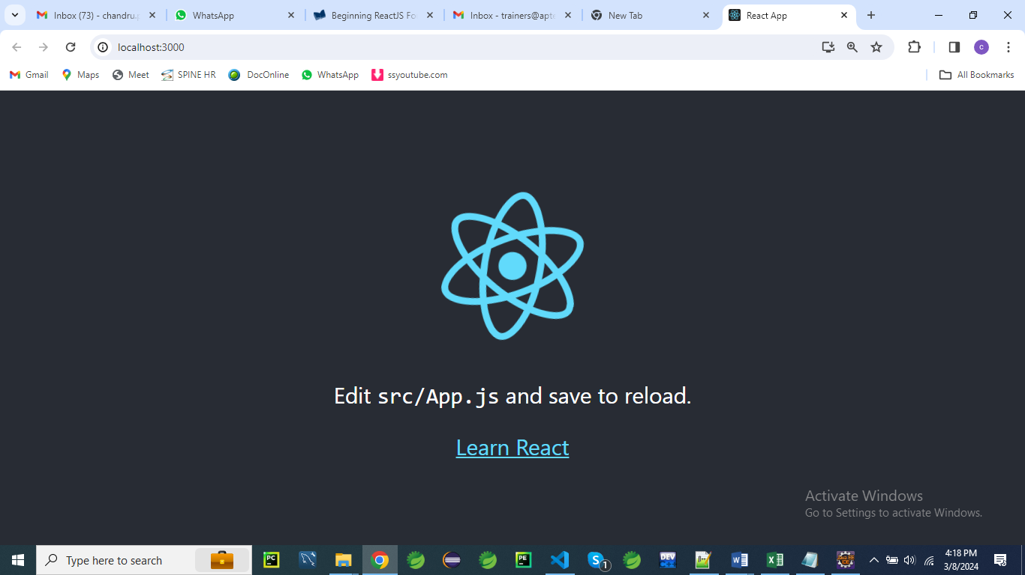

Now that you’ve created a React app, you can try making some changes to it by following these steps:

1. Leave the integrated Terminal in Visual Studio Code open and open src/App.js, which is located inside your application’s folder.

2. Find the part of App.js that contains the code shown below

<div className="App">

      <header className="App-header">

        <img src={logo} className="App-logo" alt="logo" />

        <p>

          Edit <code>src/App.js</code> and save to reload.

        </p>

        <a

          className="App-link"

          href="https://reactjs.org"

          target="_blank"

          rel="noopener noreferrer"

        >

          Learn React

        </a>

      </header>

 </div>

NOTE: The HTML-like syntax you see here is JSX, which is a special feature of React projects.

3. Change the text between the <p> and </p> tags and then save App.js as shown below

<p>

Welcome to react learning....

</p>

The whole code should look like this

<div className="App">

      <header className="App-header">

        <img src={logo} className="App-logo" alt="logo" />

**<p>**

**Welcome to react learning....**

**</p>**

        <a

          className="App-link"

          href="https://reactjs.org"

          target="_blank"

          rel="noopener noreferrer"

        >

          Learn React

        </a>

      </header>

    </div>

The output should be look like below

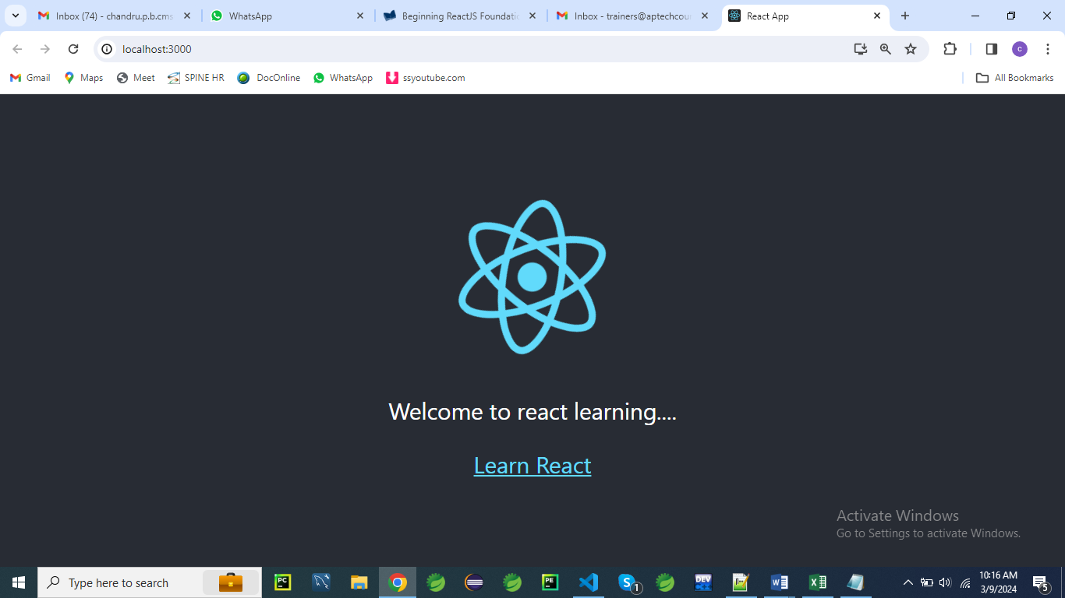

**Creating a Calculator application**

Here is a simple React program that allows you to perform mathematical operations like addition, subtraction, multiplication, and division:

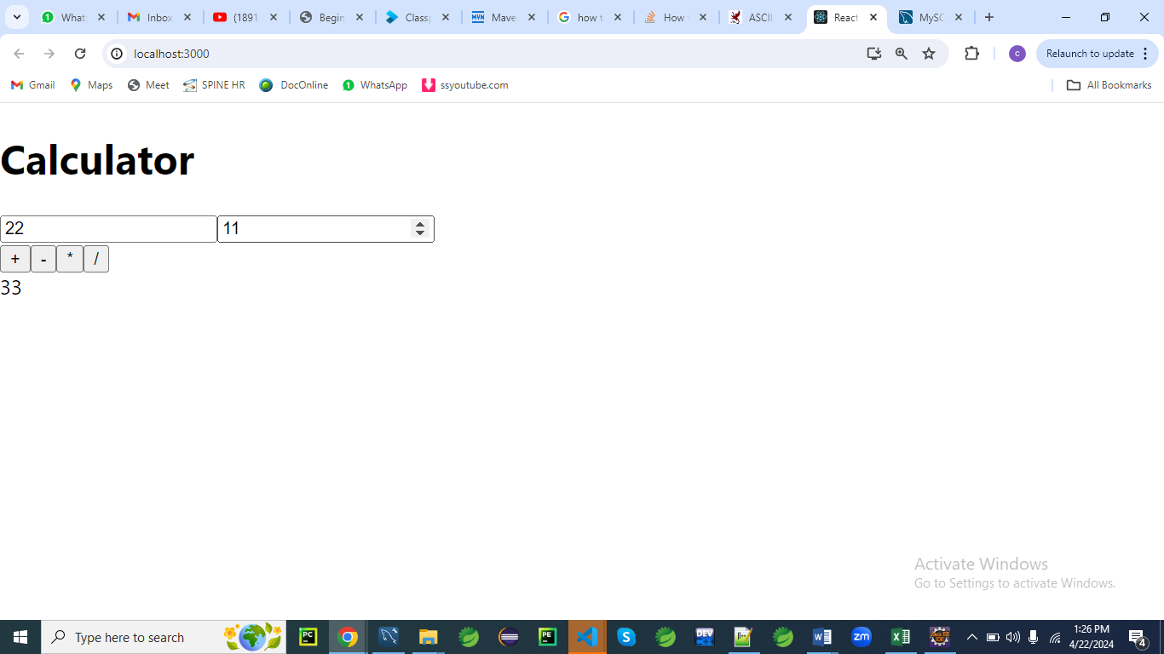

**Calculator.js**

import React, { useState } from 'react';

function Calculator() {

const [num1, setNum1] = useState('');

const [num2, setNum2] = useState('');

const [result, setResult] = useState('');

const handleNum1Change = (e) => {

setNum1(e.target.value);

};

const handleNum2Change = (e) => {

setNum2(e.target.value);

};

const handleAdd = () => {

setResult(parseFloat(num1) + parseFloat(num2));

};

const handleSubtract = () => {

setResult(parseFloat(num1) - parseFloat(num2));

};

const handleMultiply = () => {

setResult(parseFloat(num1) * parseFloat(num2));

};

const handleDivide = () => {

setResult(parseFloat(num1) / parseFloat(num2));

};

return (

<div>

<h2>Simple Calculator</h2>

<input type="number" value={num1} onChange={handleNum1Change} />

<input type="number" value={num2} onChange={handleNum2Change} />

<button onClick={handleAdd}>+</button>

<button onClick={handleSubtract}>-</button>

<button onClick={handleMultiply}>*</button>

<button onClick={handleDivide}>/</button>

<p>Result: {result}</p>

</div>

);

}

export default Calculator;

**Explanation:**

**1. What is a hook in React?**

In React, a **hook** is a special function that allows you to "hook into" React state and lifecycle features from functional components.

Before the introduction of hooks, state and lifecycle methods were only available in class components.

With hooks, functional components can have state and utilize other React features.

Hooks provide a way to reuse stateful logic across components without changing the component hierarchy.

They also allow developers to write more modular and cleaner code.

React provides several built-in hooks such as **useState**, **useEffect**, **useContext**, and **useReducer**.

Developers can also create custom hooks to encapsulate reusable logic.

Here's a brief overview of some commonly used React hooks:

1. **useState**: Allows functional components to manage state.
2. **useEffect**: Performs side effects in functional components, such as data fetching, DOM manipulation, and subscriptions.
3. **useContext**: Accesses the React context within a functional component.
4. **useReducer**: Alternative to **useState** for managing more complex state logic.
5. **useRef**: Returns a mutable ref object whose **.current** property can hold a value. It's often used for accessing the DOM or storing mutable values.
6. **useCallback** and **useMemo**: Memoizes values or functions to optimize performance by preventing unnecessary re-renders.

Hooks have greatly simplified the process of building React applications, enabling developers to write more concise and expressive code while maintaining the benefits of functional components.

**2. What do you mean by array destructuring in React?**

**Array destructuring** in React, or in JavaScript in general, is a convenient way to extract multiple values from an array and assign them to variables in a single statement.

This feature allows you to unpack values from arrays or other iterable objects into distinct variables.

In the context of React, array destructuring is commonly used with hooks like **useState** and **useEffect** to extract state variables and their corresponding update functions.

Here's an example using **useState**:

**const [count, setCount] = useState(0);**

In this code:

* **useState(0)** initializes a state variable named **count** with an initial value of **0**.
* **[count, setCount]** uses array destructuring to assign the first value returned by **useState(0)** (the state variable) to the variable **count**, and the second value (the update function) to the variable **setCount**.

After this line executes, you can use **count** to access the current state value and **setCount** to update it.

Array **destructuring** is not limited to hooks; it's a general feature of JavaScript.

You can use it to extract values from arrays returned by functions, received as function parameters, or stored in variables.

It provides a concise and readable way to work with arrays and iterable objects.

Top of Form

3. **What is the meaning of this line const [num1, setNum1] = useState('');?**

This line of code is from React, specifically using the **useState** hook.

Let's break it down:

* **useState('')**: This is a hook in React that allows functional components to manage state. It initializes a state variable with an initial value of **''**, which is an empty string.
* **const [num1, setNum1]**: This line uses array destructuring to declare two variables (**num1** and **setNum1**) and assign them values returned by **useState('')**.
  + **num1** is the state variable itself. In this case, it's initialized with an empty string.
  + **setNum1** is a function that can be used to update the value of **num1**. When you call **setNum1(newValue)**, React will re-render the component, and **num1** will have the new value **newValue**.

So, essentially, this line sets up a state variable **num1** initialized with an empty string, and a function **setNum1** to update the value of **num1**.

To use this calculator, create a new React component file (e.g., **Calculator.js**) and paste the code above into it.

Then, you can import and render the **Calculator** component in your main **App.js** or wherever you want to use it:

import React from 'react';

import Calculator from './Calculator';

function App() {

return (

<div>

<Calculator />

</div>

);

}

export default App;

This code creates a simple calculator with two input fields for numbers (**num1** and **num2**) and buttons for addition, subtraction, multiplication, and division.

The result of the operation is displayed below the buttons.

**Calculator with CSS**

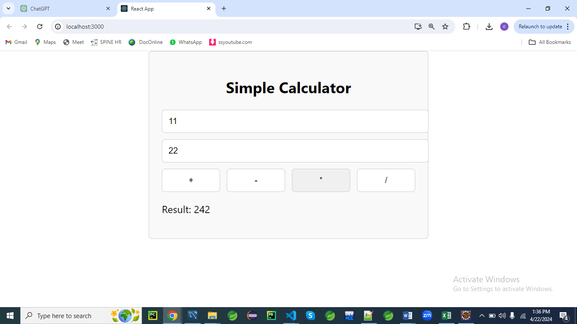

**Calculator.js**

import React, { useState } from 'react';

import './Calculator.css'; // Import the CSS file

function Calculator() {

const [num1, setNum1] = useState('');

const [num2, setNum2] = useState('');

const [result, setResult] = useState('');

const handleNum1Change = (e) => {

setNum1(e.target.value);

};

const handleNum2Change = (e) => {

setNum2(e.target.value);

};

const handleAdd = () => {

setResult(parseFloat(num1) + parseFloat(num2));

};

const handleSubtract = () => {

setResult(parseFloat(num1) - parseFloat(num2));

};

const handleMultiply = () => {

setResult(parseFloat(num1) * parseFloat(num2));

};

const handleDivide = () => {

setResult(parseFloat(num1) / parseFloat(num2));

};

return (

<div className="calculator">

<h2>Simple Calculator</h2>

<input type="number" value={num1} onChange={handleNum1Change} />

<input type="number" value={num2} onChange={handleNum2Change} />

<div className="button-group">

<button onClick={handleAdd}>+</button>

<button onClick={handleSubtract}>-</button>

<button onClick={handleMultiply}>*</button>

<button onClick={handleDivide}>/</button>

</div>

<p className="result">Result: {result}</p>

</div>

);

}

export default Calculator;

**Calculator.css**

.calculator {

max-width: 400px;

margin: 0 auto;

padding: 20px;

border: 1px solid #ccc;

border-radius: 5px;

background-color: #f9f9f9;

}

.calculator h2 {

text-align: center;

}

.calculator input {

width: 100%;

margin-bottom: 10px;

padding: 10px;

border: 1px solid #ccc;

border-radius: 5px;

}

.button-group {

display: flex;

justify-content: space-between;

}

.button-group button {

width: 23%;

padding: 10px;

border: 1px solid #ccc;

border-radius: 5px;

background-color: #fff;

cursor: pointer;

}

.button-group button:hover {

background-color: #f0f0f0;

}

.result {

font-size: 18px;

font-weight: bold;

text-align: center;

margin-top: 20px;

}

**App.js**

import React from 'react';

import Calculator from './Calculator';

function App() {

return (

<div>

<Calculator />

</div>

);

}

export default App;

**What is JSX in react?**

JSX, or JavaScript XML, is a syntax extension for JavaScript used in React.

It allows you to write HTML-like code within JavaScript files.

JSX makes it easier to create and visualize the structure of user interfaces in React by providing a more intuitive way to define components and their structure.

Here’s a quick breakdown of how JSX works:

1. **HTML-like Syntax**: JSX looks similar to HTML.

**For example:**

const element = <h1>Hello, world!</h1>;

<div>

        {element}

</div>

1. **Embedding Expressions**: You can embed JavaScript expressions within JSX using curly braces {}:

const name = 'John';

const element = <h1>Hello, {name}!</h1>;

1. **Attributes**: JSX allows you to use attributes similar to HTML attributes, but in camelCase:

const element = <img src="logo.png" alt="Logo" />;

1. **Children**: JSX can include children, making it possible to nest components:

const element = (

<div>

<h1>Hello, world!</h1>

<p>Welcome to React.</p>

</div>

);

1. **Expressions in JSX**: Any valid JavaScript expression can be embedded within curly braces:

const number = 5;

const element = <p>{number * 2}</p>; // Displays "10"

1. **JavaScript Functions**: You can define and use functions within JSX to create dynamic content:

function formatDate(date) {

return date.toLocaleDateString();

}

const element = <p>{formatDate(new Date())}</p>;

Under the hood, JSX is transformed into regular JavaScript function calls by tools like Babel.

For instance, the JSX above might be transformed into:

const element = React.createElement('h1', null, 'Hello, world!');

This makes JSX a powerful tool for creating user interfaces in React by combining the declarative nature of HTML with the power of JavaScript.

Here are a few simple programs to demonstrate JSX in React.

**1. Basic JSX Example**

This example shows how you can use JSX to create a simple element.

// App.js

import React from 'react';

function App() {

return <h1>Hello, world!</h1>;

}

export default App;

**Explanation**:

Here, App is a React component that returns a JSX element <h1>Hello, world!</h1>.

This will render a heading with the text "Hello, world!".

**2. Using JSX with JavaScript Expressions**

This example demonstrates embedding JavaScript expressions within JSX.

// App.js

import React from 'react';

function App() {

const name = 'John';

return <h1>Hello, {name}!</h1>;

}

export default App;

**Explanation**:

The {name} inside the JSX will be replaced by the value of the name variable, resulting in "Hello, John!" being displayed.

**3. JSX with Attributes**

This example shows how to use attributes in JSX.

// App.js

import React from 'react';

function App() {

return <img src="logo.png" alt="Logo" />;

}

export default App;

**Explanation**:

This JSX code creates an img element with the src and alt attributes.

logo.png will be used as the image source, and "Logo" will be the alternate text.

**4. JSX with Nested Elements**

This example illustrates how to nest JSX elements.

// App.js

import React from 'react';

function App() {

return (

<div>

<h1>Welcome to React!</h1>

<p>This is a simple example of JSX.</p>

</div>

);

}

export default App;

**Explanation**:

The div element contains two children: an h1 and a p.

This shows how JSX can be used to create a nested structure of elements.

**5. JSX with JavaScript Functions**

This example demonstrates using a JavaScript function within JSX.

// App.js

import React from 'react';

function formatDate(date) {

return date.toLocaleDateString();

}

function App() {

return <p>Today's date is {formatDate(new Date())}</p>;

}

export default App;

**Explanation**:

The formatDate function is called within JSX to format and display the current date.

{formatDate(new Date())} will be replaced with the formatted date.

These examples cover basic use cases for JSX in React.

They illustrate how JSX can make it easier to work with the structure and content of your UI components.

**6. Conditional Rendering in JSX**

This example shows how to conditionally render elements in JSX.

// App.js

import React from 'react';

function App() {

const isLoggedIn = true;

return (

<div>

<h1>Welcome to React!</h1>

{isLoggedIn ? <p>You are logged in.</p> : <p>Please log in.</p>}

</div>

);

}

export default App;

**Explanation**:

The {isLoggedIn ? <p>You are logged in.</p> : <p>Please log in.</p>} part conditionally renders one of the two paragraphs based on the value of isLoggedIn.

**7. Mapping an Array to JSX Elements**

This example demonstrates how to use the map function to create a list of JSX elements.

// App.js

import React from 'react';

function App() {

const items = ['Apple', 'Banana', 'Cherry'];

return (

<ul>

{items.map(item => <li key={item}>{item}</li>)}

</ul>

);

}

export default App;

**Explanation**:

The map function iterates over the items array, creating an li element for each item.

The key attribute is used to uniquely identify each list item.

**8. Event Handling in JSX**

This example shows how to handle events in JSX.

// App.js

import React from 'react';

function App() {

function handleClick() {

alert('Button clicked!');

}

return (

<button onClick={handleClick}>Click Me</button>

);

}

export default App;

**Explanation**:

The onClick attribute is used to handle the click event on the button.

When the button is clicked, the handleClick function is called, displaying an alert.

**9. Inline Styles in JSX**

This example demonstrates how to apply inline styles in JSX.

// App.js

import React from 'react';

function App() {

const divStyle = {

color: 'blue',

backgroundColor: 'lightgray',

padding: '10px',

borderRadius: '5px'

};

return (

<div style={divStyle}>

This is a styled div.

</div>

);

}

export default App;

**Explanation**:

The style attribute is used to apply inline styles to the div element.

The divStyle object contains the CSS properties in camelCase.

**10. Using Props in JSX**

This example shows how to pass and use props in a React component.

// App.js

import React from 'react';

function Greeting(props) {

return <h1>Hello, {props.name}!</h1>;

}

function App() {

return <Greeting name="Alice" />;

}

export default App;

**Explanation**:

The Greeting component takes a name prop and uses it within the JSX.

The App component passes the prop value "Alice" to Greeting.

**11. Fragments in JSX**

This example demonstrates using fragments to group multiple elements without adding extra nodes to the DOM.

// App.js

import React from 'react';

function App() {

return (

<>

<h1>Fragment Example</h1>

<p>This is a paragraph.</p>

</>

);

}

export default App;

**Explanation**:

The <> and </> syntax is used to create a fragment that groups the h1 and p elements without adding an extra div or other wrapper element to the DOM.

These additional examples illustrate various features and techniques in JSX, showcasing its flexibility and power in building React applications.

**Components in React**

In React, a "component" is a fundamental building block used to create user interfaces.

Components are reusable, encapsulated units that can represent a specific part of the UI, such as a button, a form, or an entire page layout.

They encapsulate logic, styles, and state, allowing developers to create modular and maintainable applications.

Here's an overview of what components in React are and why they are essential:

**What are Components?**

* **Encapsulation**: Components encapsulate both the logic and the presentation of a specific part of a user interface. This encapsulation promotes reusability and modularity.
* **Reusable Building Blocks**: Components can be used and reused throughout an application or even across different projects. This reusability leads to more consistent code and faster development.
* **Composition**: Components can contain other components, allowing for complex UIs to be built from smaller, simpler components.

**Types of Components**

* **Functional Components**: These are stateless by default but can use React Hooks to manage state and lifecycle events. They are lightweight and the preferred way to write components in modern React.

**Greeting.js**

const Greeting = ({ name }) => {

return <div>Hello, {name}!</div>;

};

export default Greeting;

**App.js**

function App() {

  return (

    <div>

     <Greeting name='Chandru'/>

    </div>

  );

}

* **Class Components**: These components use ES6 classes and are more heavyweight. They were the primary way to create components before the introduction of hooks. Class components use lifecycle methods and **this.state** for state management.

**Greeting.js**

class **Greeting** extends React.Component {

render() {

return <div>Hello, {this.props.name}!</div>;

}

}

export default Greeting;

**App.js**

import Greeting from './Greeting';

function **App**() {

  return (

    <div>

     <Greeting name='Chandru'/>

    </div>

  );

}

**Component Communication**

* **Props**:
  + Props (short for "properties") are the way data is passed from parent components to child components.
  + Props are read-only, meaning that a component can't change the props it receives from its parent.

**Child.js**

const **Child** = (props) => {

return (

<div>{props.message}</div>

);

};

export default Child;

**Parent.js**

import Child from './Child'

const **Parent** = () => {

return <Child message="Hello, World!" />;

};

export default Parent;

**App.js**

import Parent from './Parent';

// props

const **App** = () => {

  return(

    <Parent/>

  );

}

* **State**:
  + State represents mutable data within a component.
  + Functional components use the **useState** hook to manage state, while class components use **this.state** and **this.setState**.
  + State changes trigger re-renders, allowing components to respond dynamically to changes in data

const Counter = () => {

const [count, setCount] = useState(0);

const increment = () => setCount(count + 1);

return (

<div>

<p>Count: {count}</p>

<button onClick={increment}>Increment</button>

</div>

);

};

**Component Lifecycle**

* **Lifecycle**: Components have lifecycles, from mounting (when they first appear) to updating (when state or props change) to unmounting (when they are removed). In functional components, you manage lifecycles with the **useEffect** hook.

const Timer = () => {

useEffect(() => {

const timer = setInterval(() => console.log("Tick"), 1000);

return () => clearInterval(timer); // Cleanup on unmount

}, []);

return <div>Timer is running...</div>;

};

**Component Best Practices**

* **Single Responsibility**: Components should have a single responsibility, making them easier to understand and maintain.
* **Modular Design**: Build applications by composing smaller components. This approach leads to more maintainable and scalable code.
* **Reusability**: Design components to be reusable and flexible. Pass data through props and avoid hardcoding specific logic or styles.

**Conclusion**

Components in React are the basic building blocks of any React application.

They allow developers to create complex user interfaces by composing and reusing smaller units.

By mastering the use of components, you can create scalable, maintainable, and modular React applications.

**Example of Component**

Creating a simple React component involves setting up a basic component structure, defining its appearance and behavior, and integrating it into a larger React application.

Here's a simple example of a functional component in React, which is the preferred method for creating components since React 16.8, when React Hooks were introduced.

**Simple Functional Component**

Let's create a simple component that displays a greeting message.

We'll pass the name to be greeted as a prop.

**Greeting.js**

import React from 'react';

// Define the Greeting component

const Greeting = ({ name }) => {

return <h1>Hello, {name}!</h1>;

};

export default Greeting;

**Explanation:**

* **Functional Component**: The **Greeting** component is a functional component, meaning it is defined as a JavaScript function. Functional components are simple and typically use React Hooks for state and lifecycle management.
* **Props**: The **name** prop is passed to the component, allowing it to dynamically display different greetings depending on the input.
* **JSX**: JSX is a syntax extension for JavaScript that looks similar to HTML but allows for embedding JavaScript expressions. The **Greeting** component returns a JSX element—a heading with a greeting message.

**Integrating the Component into a React Application**

To use this component in a larger React application, you would import it into a parent component and pass the required props.

Here's an example where the **Greeting** component is used within another component:

import React from 'react';

import Greeting from './Greeting'; // Import the Greeting component

const App = () => {

return (

<div>

<Greeting name="Alice" /> {/* Use the Greeting component with the name prop */}

</div>

);

};

export default App;

**Explanation**

* **Parent Component**: The **App** component serves as the parent component where we import and use the **Greeting** component.
* **Using Props**: The **Greeting** component is used with the **name** prop set to "Alice". This allows the component to display the appropriate greeting message.

**Running the Example**

To run this example in a React application, you would need a development environment set up with Node.js and a tool like Create React App.

If you're using Create React App, you can add the **Greeting** component to the **src** folder and update the **App.js** file to include it, as shown above.

Afterward, start the development server, and you should see the greeting message in your browser.

This simple example demonstrates the basic structure of a React component, how to pass props to it, and how to integrate it into a larger application.

You can build upon this foundation to create more complex components and applications in React.

**Class Component**

A class component in React is a component defined using an ES6 class that extends the **React.Component** base class.

Class components were the primary way to define components in React before the introduction of functional components with hooks.

They support features like local state management and lifecycle methods, allowing you to define complex behavior within the component.

Here is an overview of what a class component is and an example program to illustrate its use:

**What is a Class Component?**

* **Inheritance**: Class components inherit from **React.Component**, giving them access to various features like state management and lifecycle methods.
* **State Management**: Class components can have internal state, defined using **this.state**, and can update this state with **this.setState**.
* **Lifecycle Methods**: Class components support various lifecycle methods, like **componentDidMount**, **componentDidUpdate**, and **componentWillUnmount**, which control what happens at different stages in the component's life cycle.

**Example Program for a Class Component**

Here's a simple example of a class component that manages a counter state and provides a button to increment the counter.

**Counter.js**

import React from 'react';

class Counter extends React.Component {

constructor(props) {

super(props);

// Initialize the state with a count of 0

this.state = {

count: 0,

};

}

// Method to increment the count

increment = () => {

this.setState((prevState) => ({

count: prevState.count + 1,

}));

};

render() {

// Use this.state to access the current state

return (

<div>

<p>Current count: {this.state.count}</p>

<button onClick={this.increment}>Increment</button> {/* Button to increment */}

</div>

);

}

}

export default Counter;

**Explanation**

* **Constructor**: The **Counter** component's constructor initializes the state. It also calls **super(props)** to ensure the base class is initialized correctly.
* **State**: The **count** state is initialized to 0 in the constructor. Class components use **this.state** to manage internal state.
* **Method Definition**: The **increment** method updates the state using **this.setState**. The **setState** method schedules a re-render with the updated state.
* **Rendering**: The **render** method returns the JSX for the component. It displays the current count and a button that, when clicked, increments the count.
* **Event Handling**: The button uses the **onClick** event to call the **increment** method when clicked.

**Using the Class Component**

To use this class component in a React application, you would import it into another component or a main application file, like **App.js**, and include it in the JSX:

import React from 'react';

import Counter from './Counter'; // Import the Counter class component

const App = () => {

return (

<div>

<Counter /> {/* Use the Counter class component */}

</div>

);

};

export default App;

**Key Points**

While class components offer robust functionality with state and lifecycle management, functional components with hooks are now the preferred approach in modern React development.

Class components are still used in existing codebases and in some specific scenarios, but for new development, most developers opt for functional components due to their simplicity and React Hooks' flexibility.